PHYSICS AND SPIRITUALITY UNIFIED

By Ron Pearson 27/11/11

This unification, which showed a spiritual realm must exist, arose in a surprising way: it was unintended! It arose as a result of finding solutions to several problems in cosmology-physics. Some of these had proved vexed questions for several decades.
What is now called the ‘Big Breed’ theory arose from my attempt to solve a major problem of the Big Bang theory that purports to describe and explain creation of the universe. The latter predicts an absurdly high rate of expansion. It is known as ‘The problem of the cosmological constant’ that has been troubling cosmologists since 1980.
A big bonus for the resulting solution, which eliminated the difficulty, was that by 1992 it had predicted the universe must exist in a state of ever-accelerating expansion, and at about the observed rate. This was inherent in the publication by the Russian Academy of Science, Pearson (1994) and America Pearson (1997), the latter being a scientific journal.
Three astronomers have just been awarded the Nobel Prize for discovering this acceleration, published by Schwarzchild (1998). It shook the cosmologists who all thought the expansion was decelerating. However, they then invented some all-pervading substance called ‘Dark Energy’ with long range powers of repulsion by way of explanation. They all admit, however, that the whole thing is an unresolved mystery.
What is the use of such speculation when they still have no solution to their major problem of the Big Bang that dwarfs to insignificance anything their Dark Energy could do?

Great support for the Big Breed theory had therefore appeared by 1998, since no other theory has yet solved the major problem or solved the Dark Energy Mystery.

Briefly how the Dark Energy Mystery was Resolved
This new solution for the creation problem demanded that an ultimate reality existed at an even deeper level than had previously been accepted. The ultimate had to be made of two opposite kinds of energy existing in the form of minute particles I called ‘primaries’. This was necessary in order to allow creation from the void of nothing to happen without violating any laws of physics. Then logic showed that when opposite primaries collided only in twos, then both increased in energy of their own kind. They all kept growing bigger until each of them split in two. They were breeding! However, when numbers grew and they started packing closely, mutual annihilation set in to cancel most of the creation still going on. It was this annihilation that solved the problem from which the Big Bang still suffers. However, the logic shows a minute net creation remains and results in the prediction of a universe in a state of ever-accelerating expansion of about the correct rate.

And now we come to the unification with spirituality.
Matter had, however, not yet appeared. So far only the origin and growth of the ultimate reality has been touched upon. The annihilation of primaries, as will be seen later, produced a filamentous structure. These are not of matter but were the essential precursors to matter. The structure had the potential to self-organise, ultimately to become a conscious intelligence. It was a huge growing ball yet of finer grain size than any part of an atom. Our minds are part of this background structure who then co-operated to organise the creation of matter in the manner of a three dimensional virtual reality. The remaining, and overwhelmingly greater part of the structure, could be used like a computing system that was also used as the display screen. All the atoms are simply energy organised by information. They were designed to self-replicate. However, the replication had an inbuilt cut off feature. In this way a big bang was organised that solved the problems from which the current theory still suffers.
Clearly our minds can now be seen, not as mere brain function, but as parts of the ultimate background medium. They are ‘souls’ - potentially immortal and constitute part of the true reality. Contrary to our perceptions, matter is not truly real but is more like an illusory cloak. This has been deliberately organised, by a consortium of minds, to provide each mind with a temporary habitat.

For those wishing to see more detail the following expansion is provided.

The Major Problem that still Invalidates the Big Bang
The universe of matter is actually made out of energy. The problem was that the big bang posited that all the energy needed to make the universe appeared from nothing in a blinding flash that only lasted for a split second. Then the creation had to switch off. Unfortunately, theorists could find no way to do the switching-off and so the theory predicted the hopelessly high rate of expansion of the universe. In fact this, ‘Problem of the cosmological constant’, is 1,000 ….to 120 zeros faster than is remotely possible!
I wrote, in 1987, to Prof. Paul Davies (see book 1989) about an associated problem that I had noticed contained a flaw. In reply he included the Big Bang theory as derived by Dr Alan Guth in 1980. I was horrified to find more flaws! Flaws in logic occurred in almost every line of the derivation. The reason for the huge error it produced had become startlingly clear.
Since this theory had passed peer review and had become established, it was also clear that the theorists had lost important expertise that now resided in my own discipline of mechanical engineering. I knew I would be able to provide an alternative derivation that, being based on sound logic, ought to solve this major problem. I felt the need existed to offer some help in order to return the expertise required to the discipline of physics. With this benign intention in mind, and under the impression that the cross fertilisation between disciplines is encouraged, I made a start.

I now need to explain why two different kinds of energy need to exist before introducing the Big Breed theory. This is best done by relating a brief history of the project.

Why an Alternative to Relativity had first to be derived
Newton’s theories of mechanics and gravitation are normally all that the engineer requires. But now an extension was needed to allow speeds up to that of light and also in extreme gravitational fields to be included. Only Einstein’s theories of relativity were available that permitted calculations under these conditions to be made. Unfortunately ‘special relativity’, which only considers uniform motion in a straight line, could not be used. It was inconsistent with the existence of any background medium such as the old ‘aether’ or the modern ‘quantum vacuum’ (which is not nothing. It is more like a gas).
Even the Big Bang theory has to accept this background medium exists. Usually they just call it ‘space’ for short instead of quantum vacuum but it means the same thing.
The first requirement was therefore the need to derive a new mechanics to replace Einstein’s special relativity. Then his second theory, ‘general relativity’, which includes acceleration and gravity, also turned out to be unsatisfactory. It is incompatible with quantum theory. The latter is the theory of the atom and is quite different from the mechanics that needs to be used for large scale things like balls or planets. Even so the two theories need to be consistent with one another and all physicists lament they are not. Indeed theorists have been trying since the 60’s to match up these two theories and are still engaged on this futile search without any prospect of success still in sight.
A major reason for the mismatch is the unimaginable concept called, ‘Curved space-time’ that substitutes for a force of gravity in Einstein’s theory of general relativity. This makes it incompatible with quantum theory that needs such a force to exist. What amazes me is that theorists still struggle in attempts to achieve the impossible.
Clearly one needed to start again and derive a satisfactory alternative to both theories of relativity. This appeared very challenging at first but I was surprised to discover that it was not so difficult after-all and a satisfactory general equation appeared within a few days. This was based on the straight-line geometry of Euclid and universal time, just as did Newton’s mechanics. Einstein’s curved space-time, for example, was replaced by non-uniform space density: it reduced with altitude just as air does. This yields the same end equations in a simpler way. I will show later how ‘time dilation’ was satisfied.
In consequence 1988 was a most exciting and rewarding year. I had to derive secondary equations from the general one in order to compare predictions of the theory with existing experimental observation. This took several months but one by one each check showed rewarding agreement without any attempt or need to modify the general equation. It predicted the doubling of deflection of starlight grazing the sun as compared to that given by Newton’s equations. It matched the Shapiro Time delay caused by the speed of light slowing as it approached the sun. It gave exactly the same equation as Einstein’s for the perihelion advance of planets.
But how, you may ask, could such a theory predict ‘time dilation’ when time has been assumed a universal constant? The answer is simple. Time dilation is an illusion that does not exist. Instead clocks lose time for mechanical and magnetic reasons.
For example, the same famous equation E = mc² appeared a different way from Einstein’s method. That equation says E, meaning energy, and mass m are equivalent, being connected by the speed of light c.
The new approach considered the horizontal acceleration of an object and this makes things easier to understand. Energy has to be supplied to an object to make it accelerate and adds to the energy originally present. The end result meant that any object has to be made from two kinds of energy. It has to be made from ‘rest energy’ when it is standing still in the background medium. The energy needed to cause acceleration means that motion also has a form of energy. This is called ‘kinetic energy’. Out comes E = mc² showing there has to be a corresponding kinetic mass. So when an object is accelerated its mass also increases.
Make the balance wheel of a clock more massive and the clock ticks more slowly so it loses time when accelerated to a higher linear speed. Dr Louis Essen FRS (famous inventor of the atomic clock) showed that Einstein broke the rules of logic by fixing the speed of light c as a universal constant. It was because of this that he found time had to change. With time fixed, as in the alternative approach, c reduced as altitude reduced. However, the rest energy of an object turned out to be a universal constant. Therefore the mass had to increase to compensate for the reduction in c. Again clocks slowed as altitude reduced due to increased mass. Exactly the same equation appears as in Einstein’s ‘gravitational time dilation’ but the meaning is totally different. Despite such differences in meaning, of which this is but one example, both theories are supported equally well by all the experimental checks. Now, however, internal contradiction and incompatibility with quantum theory have been eliminated.
The new approach also demolished the equivalence of mass and energy. It showed energy was the one and only true building substance of the universe, with mass demoted to the property of energy that determined how it would accelerate.

All we need to understand is that every particle and object consists of the arithmetic sum of two kinds of energy, rest energy and kinetic energy. Each has a corresponding mass.
In the final analysis provided by Exact Classical Mechanics (ECM theory) only energy is seen to be the true constructional material of matter. Mass is the measure of the inertia of energy: i.e of an object. The greater the mass, the greater the force needed for acceleration.

Negative Energies – Both of those just described appear in two forms
Now we need to home in onto the creation problem. The Big Bang broke the law of ‘Energy conservation’: energy can be neither created nor destroyed. They tried to cover this by balancing the energy needed in ways that broke other laws of physics that I will not go into. However, there is a flaw-free alternative that is used in the Big Breed theory: negative energy. There is nothing strange about this as I will now explain.
Newton’s third law of motion states that to every force of action there is an equal but opposite re-action. You push an object with a force of action and that object pushes back. We assume the force of action points in the same direction as the acceleration produced. Then we find all energies, such as kinetic energy, have to be regarded as positive.
Switch both forces round and all those energies become negative. For example, the force of action now points backwards: against motion. This makes the kinetic energy of the accelerating object negative. If the entire universe were made of negative energy, however, exactly the same responses would occur when one object bumped into another. This is because the negative effects cancel out.
So, contrary to first impressions, there is nothing strange about the idea of negative energy. We now assume a background medium exists that is deeper than even the quantum vacuum and has to begin to grow from nothing. This is true reality and so operates on classical mechanics: not those of the quantum world. We will explore this to see if it could be the source of all matter and the substance of other possible interpenetrating worlds. This ultimate medium and precursor to matter consists of particles, to be called ‘primaries’ made of two opposite kinds of energy: positive and negative.
When like collides with like the responses are identical with those of colliding billiard balls, as is to be expected. Strange things happen, however, when opposites collide. They can now cancel one another to leave nothing. Alternatively the converse can happen: so allowing pure creation to occur from nothing.
But what controls which of these effects will actually apply?
The answer is that another law of physics has to be satisfied simultaneously: momentum conservation. The momentum of a particle or object is obtained by multiplying its mass by its velocity. And velocity is speed with direction specified.
Analysis has shown that when just two opposites collide, the need to conserve momentum forces both to gain kinetic energy of their own kind from the void. They keep growing bump by bump with some kinetic energy decaying to rest energy at each bump. They all grow until reaching a critical size, then just as raindrops split when they get too big, so do primaries. In consequence primaries breed like opposite sexes.
So the nothingness of the void is unstable and is liable to spontaneously create primaries, albeit initially at a very slow rate. But now we can predict an explosive development will happen if at some place many of them bump around to start things off.
Analysis shows the rate of expansion due to this collision-breeding effect is huge: it poses a problem similar to that invalidating the big bang theory though many orders of magnitude smaller. Fortunately, however, a solution immediately appears. When the primaries become very crowded, as they will, owing to the breeding going on, it is now possible for many primaries to collide simultaneously. A flow pattern can spontaneously arise in which many primaries converge from all directions to a line or point. Momentum conservation now dictates mutual annihilation. Countless billions of such patterns appear throughout the mix to almost cancel the huge creation still going on. The two processes reach equilibrium with a minute net creation remaining everywhere. And analysis shows the result is that a ball-like entity is colonising the void with a small steady and ever-accelerating growth.
The theory has predicted an ever-accelerating growth!
The need to invent Dark Energy to explain this acceleration never existed!

There is more to come.
Where annihilation occurs filaments or blobs arise made of primaries of both kinds engaged in mutual annihilation as they squeeze each other out of existence in their motion towards the annihilation centres. The structure is in a dynamic state, being energy fed all the time.
Now mathematicians studying ‘chaos theory’, as beautifully described by Gribbin (2005), have shown that in such a state the most amazing self-organisation invariably happens. Highly complex structures spontaneously appear that could never have been anticipated from the simple starting conditions. The result is a form of evolution taking place, not in matter, since that has not yet appeared. It is evolution of the background medium toward an ever increasingly organised state.

How Quantum theory is Explained
In the 1930’s it was discovered that, in the world of the atom, all aspects of reality, what we normally observe, vanish like the morning mist. All the bits comprising atoms, their ‘sub-atomic particles’ exist in limbo states until somebody tries to measure where they are. They also exist as waves, like ripples on a pond. Then where waves arising from different places cross each other strange ‘interference patterns’ arise. The particles exist mostly where the waves are strongest – and then: wait for it – they collapse into particles on observation!
To make sense of this a famous physicist, Niels Bohr, organised a conference. They came out with the ‘Copenhagen Interpretation’ that said consciousness participated in the creation of matter. Yet they still all believed that only the mortal brain was the seat of consciousness.
So I ask, “How then could matter have existed before brains evolved?”
The answer has to be that consciousness existed prior to the creation of matter and resided in the background medium. This had evolved consciousness by the self-organising power of energy fed chaos. It then designed and created matter.

Where God and Spirit come in
I call the resulting background medium the i-ther meaning ‘intelligent ether’. The structure refines spontaneously by the self-organising power of energy-fed chaos until it acquires a machine-like intelligence. Then further refinement cause small parts to develop consciousness.
God has evolved: not with a male figure shape: it is a huge ever-growing ball, yet the structure is fine grained even as compared to the tiniest sub-atomic particles. Most of i-ther remains in the form of a programmable computer with the minds existing as small more highly organised fractions. These, by thought, are able to program the remainder. God is the totality of all these minds. They all co-operated to design and create the universes of both matter and spirit.

These worlds of spirit and matter could have been designed and created in the same mathematical way. They could use organised vibrations of i-ther as constructional tools to produce what are really virtual realities - such as those we enjoy on our computer screens. There is a difference: they are fully three-dimensional. The i-ther not only carries out the computation: it uses itself as the 3 D screen on which to portray the images. The worlds of matter and spirit co-exist in the same place but, tuned to different vibrational frequencies, they are not normally visible to one another.
Our bodies are part of the picture and so, to human beings, the illusion of total reality is achieved. We are designed to experience this illusion for a while before the i-theric mind decouples to re-attach to one of the parallel worlds that interpenetrates our own: those of spirit.
The simplest way to start would have been the programming of just a few sub-atomic particles inclusive of a replication routine – rather like the viruses that infect our computers. Now, however, these viruses incorporate a replication cut-off routine. In this way a big bang of matter creation can be organised that parallels that of the established Big Bang theory. It is, however, now free of its invalidating false logic and predictions.

Now the fine grain structure includes a vast memory store that psychics call the ‘Acashic Records’. Everything that has happened is stored in them and what is expected to happen in the future is stored there also. However, the historic records are fixed but those of the future can be changed owing to the free will of minds. This fits in with experience. It shows why some people are able to make fairly accurate predictions of future events but accuracy diminishes with the time ahead. There is no need to postulate time does not exist: that instead there is an eternal ‘now’: that all is fixed and pre-ordained. If this was so free-will could not exist.
Some people of remote viewing capability claim to have travelled both into the future and into the past. What they are really doing is reading the records that provide the illusion of making such journeys.
A fascinating ‘must read’ is a new book by Brigitte Rix (2011). She is a highly developed clairaudient medium who writes the story of her deceased mother from before her death until the present. This gives a graphic account of the way one progresses in the world of spirit. A fascinating aspect is that one makes things by pure thought. And the products feel just as real and solid as do our own chairs and tables. This gives strong support to the theory by showing how the mind must be programming the i-ther.
One difficulty emerges once again: the problem of time. All communicators tell us it does not exist for them. Yet how can this be if they progress? I think they mean they have no time reference like our Sun. They can be deluded just as we can be.
[3560 words]

EXERPTS From the books
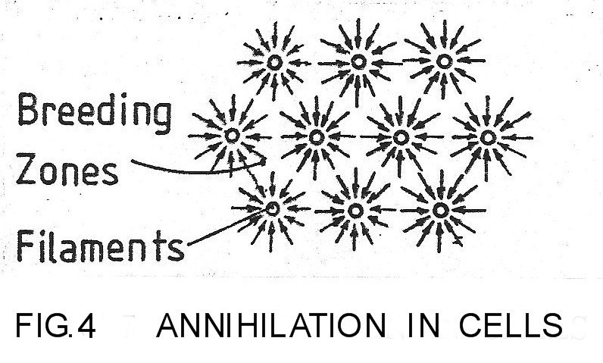
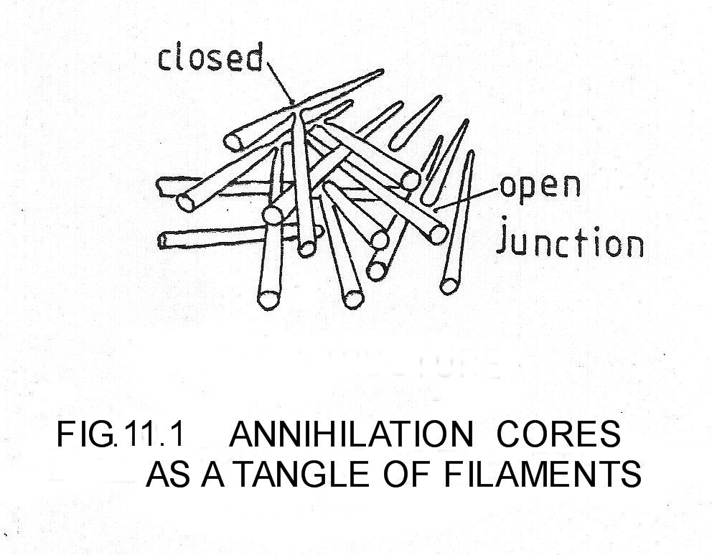
FIG.4 shows filaments end-on with primaries imploding into them. Since the net momentum of the imploding flow is zero and the primaries are of opposite energies in balanced amounts, the conditions for mutual annihilation are satisfied.

FIG. 11.1 shows the tangle of filaments as looked at from three dimensions. They grow like crystals from a melt and like them the ordered arrangement of the small scale, as suggested in FIG..4, is compromised.
A dynamic energy fed structure emerges able to self-organise by energy-fed chaos so that something similar to a neural net can emerge as illustrated in FIG.11.2.

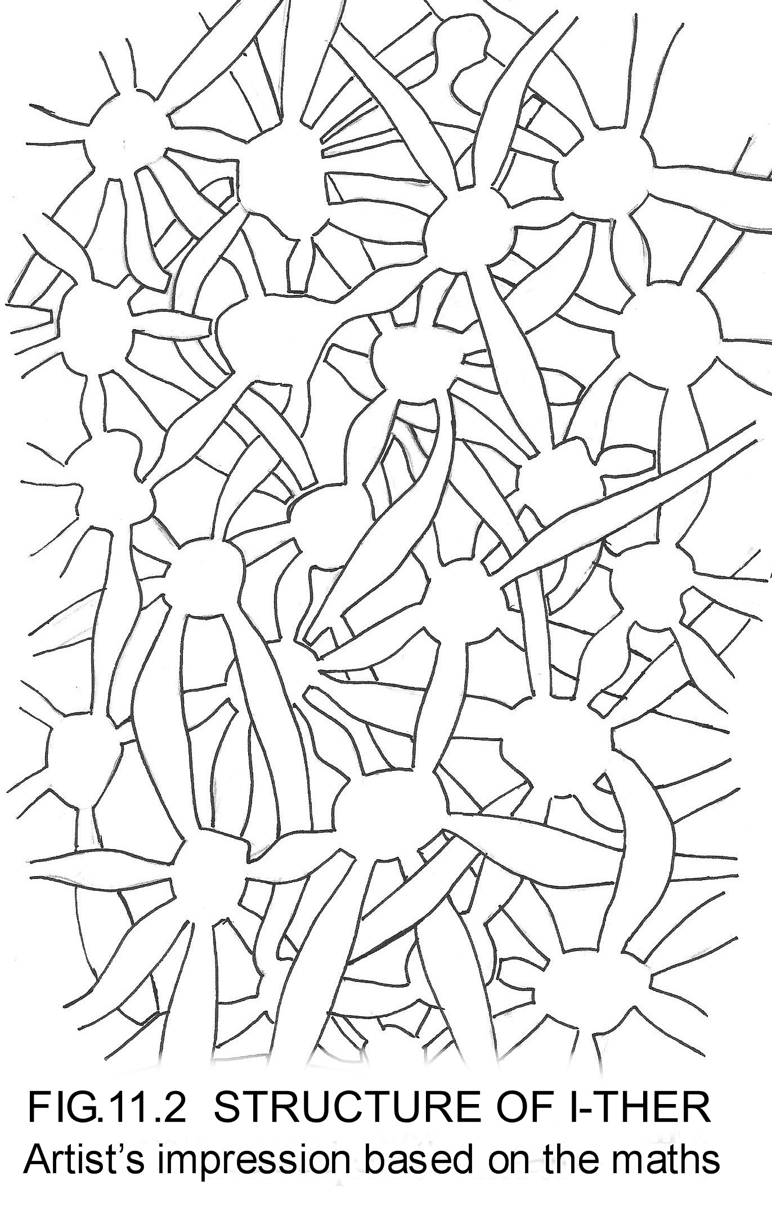
FIG 11.2 Gives an artists impression of the structure of the ultimate reality that is consistent with the mathematically based logic developed and presented in the books available.

DEFUSING THE CONFLICT
What is needed is for this material to be forwarded to the people engaged in the dispute still raging between the Creationists and Evolutionists in America.

Could these solutions provide an amicable settlement that is acceptable to both parties?

See Reference:
How Science Proves God: Defusing the Conflict

This book was written specifically to help in defusing this conflict and if anybody can put me in contact with the people concerned I will be very grateful.
References
Scientific Journals and books
Gribbin, John: (2005) Deep Simplicity: Chaos, Complexity and the
Emergence of Life.
Penguin Books Ltd., 80 Strand, London WC2R ORL
Guth, A. & Steinhardt, P.: (1989): The Inflationary Universe: pp.57-59
The New Physics Ed. Davies, Paul: Cambridge University Press
Pearson, Ronald D. (1990): Intelligence Behind the Universe!
ISBN 0 947823 21 2 Headquarters Publishing Co.Ltd.,
5 Alexandria Rd., London W134 OPP (Now out of print)
Pearson, Ronald D (1991): Alternative to Relativity including
Quantum Gravitation: Second International Conference on
Problems in Space and Time: St. Petersburg, Petrovskaja
Academy of Sciences & Arts (Sept. 1991) pp 278-292
Pearson, Ronald D, (1994).: Quantum Gravitation and the
Structured Ether: Sir Isaac Newton Conference. St. Petersburg,
Russian Academy of Sciences, (March 1993) pp 39-55
Chairman Local Organising Committee:Dr. Michael Varin:
Pulkovskoye Road 65-9-1 St. Petersburg 196140, Russia.
FAX: (7) (812) 291-81-35
Phone:Alexandre Alekseev: office:(7) (812) 291-36-73,
Home:(7) (812) 173-55-69 E-Mail: consym@saman.spb.su
Pearson, R. D.(1997): Consciousness as a Sub-Quantum
Phenomenon: Frontier Perspectives, Spring/Summer 1997,
Vol.6,No.2 pp70-78
Pearson, Ronald D. (2005): A Paradigm-Shifting Physics Supports
Immortallity: CONSCIOUSNESS SERIES 7: INDIAN COUNCIL OF
PHILOSOPHICAL RESEARCH, Darshan Bhawan, 36,Tughlakabad
Institutional Area, Mehrauli-Badarpur Road, NEW DELHI-110062
Schwarzchild, B. (1988): Very distant Supernova Suggest that the
Cosmic Expansion is Speeding Up

BOOKS
Brigitte Rix (2011) I’m NOT DEAD: I’m ALIVE without a body!
What’s it like after we die? 525 pages £10.99
www.Italkwithspirits.com

Ron Pearson
How Science Proves God: Defusing the Conflict. 111 pages
(Written for defusing the conflict still raging in America between Creationists and Evolutionists showing how the resolution could be beneficial to both sides)

Physics Hits the Buffers: Why?
Read Our Solution!
Written for young non-technical people aspiring to science: 188 pages.
This again is written as a popularisation with no maths but some equations are quoted.

CREATION SOLVED? 263 pages.

THE BIG BREED THEORY of the creation of the universe 56 pages. This paperback is a short popular introduction with many illustrations. It contains no maths or equations.

Dark Energy Mystery Solved by Big Breed Theory 312 pages. This book provides the maths (calculus) backing the theory.

Quantum Gravity via an Exact Classical Mechanics (ECM theory) 227 pages
PART I is descriptive: PART II gives full mathematical detail.

THESE BOOKS from www.bigbreed.org, www.lulu.com or www.darkenergymysterysolved.co.uk: www.pearsonianspace.com

